2020 50/50 Tree Planting
‘Exclamation’ Planetree – 2.5” caliper (60’ tall x 30’ wide at maturity) – A hybrid selection of London Planetree, selected for its uniform, upright-pyramidal habit, moderate growth rate, and resistance to anthracnose. Attractive, exfoliating bark of cream, olive and light brown color.
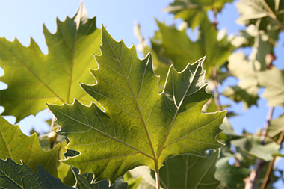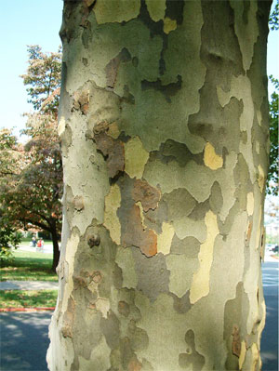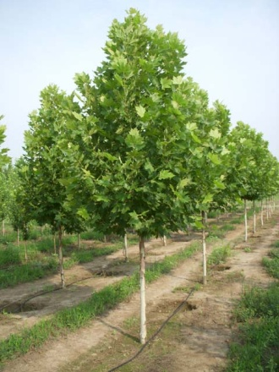

Swamp White Oak – 2.5” caliper (55’tall x 55’ wide at maturity) a medium growing, broad spreading and majestic native oak with yellow fall color.
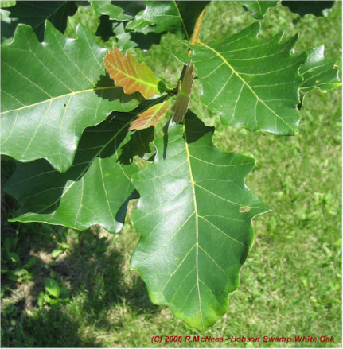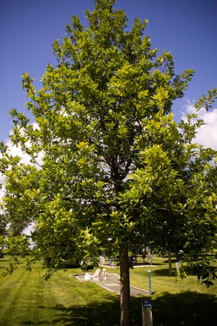

‘State Street’ Miyabe Maple- 2.5” caliper (40’ tall x 30’ wide at maturity) a medium sized, upright rounded shade tree, free of serious insect or disease problems. Good yellow fall color.
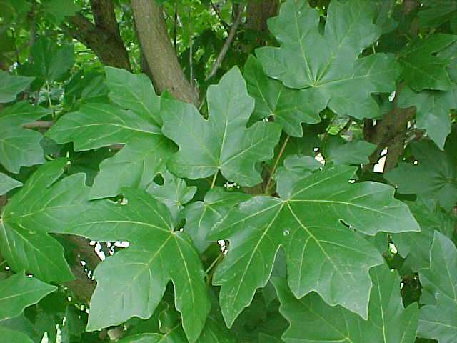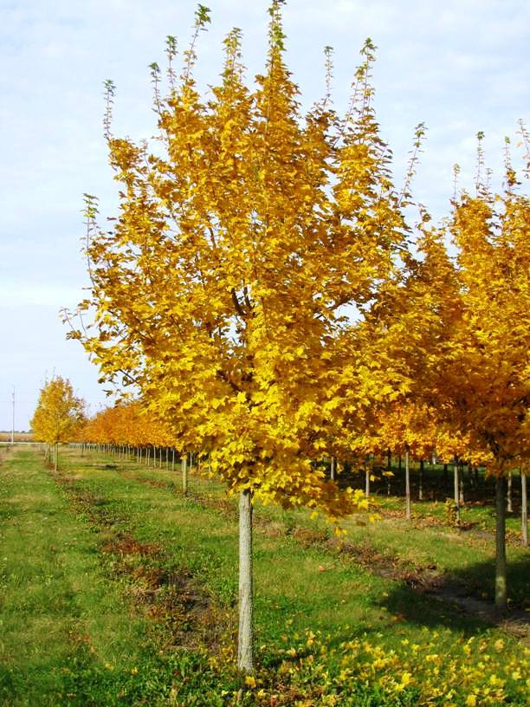

Triumph Hybrid Elm – 2.5” caliper (55’ tall X 50’ wide at maturity) a fast growing tree with shiny dark green leaves turning a nice yellow in fall. Bred for its resistance to Dutch Elm Disease and shows many of the desirable traits of the American Elm.
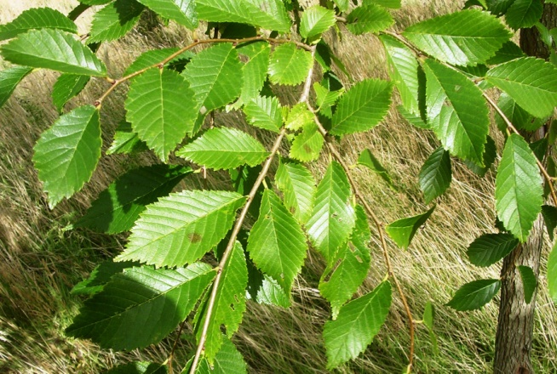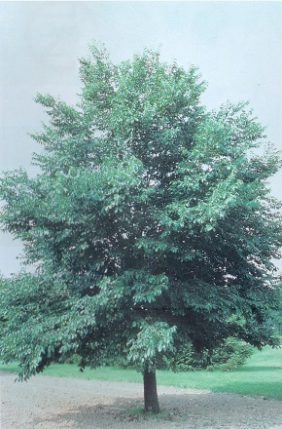

Autumn Splendor Horsechestnut- 2.5” caliper (20’ tall and 20’ wide at maturity) Medium sized horse chestnut with rounded canopy, large yellow panicles of flowers in spring and maroon fall color. Resistant to summer leaf scorch.

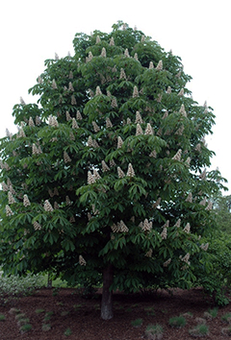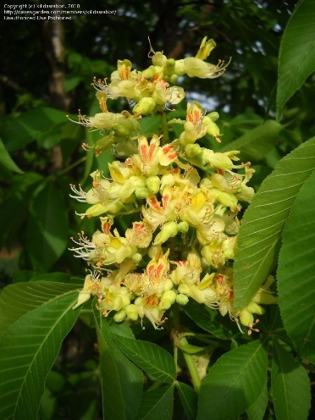

‘Ivory Silk’ Japanese Tree Lilac – 2.5” caliper (20’ tall x 15’ wide at maturity) slow growing tree of small stature that makes it suitable for planting beneath power lines. Large clusters of creamy white flowers in June.

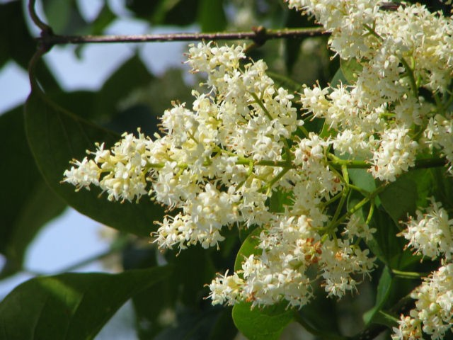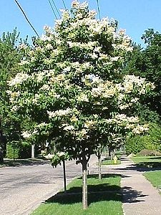

‘Renaissance Reflection’ Paper Birch -2.5” caliper (50’ tall x 25’ wide at maturity) A tall, fast-growing tree with striking bark that displays dark green foliage throughout the season, changing to a golden color in the fall. Resistant to bronze birch borer (BBB).
